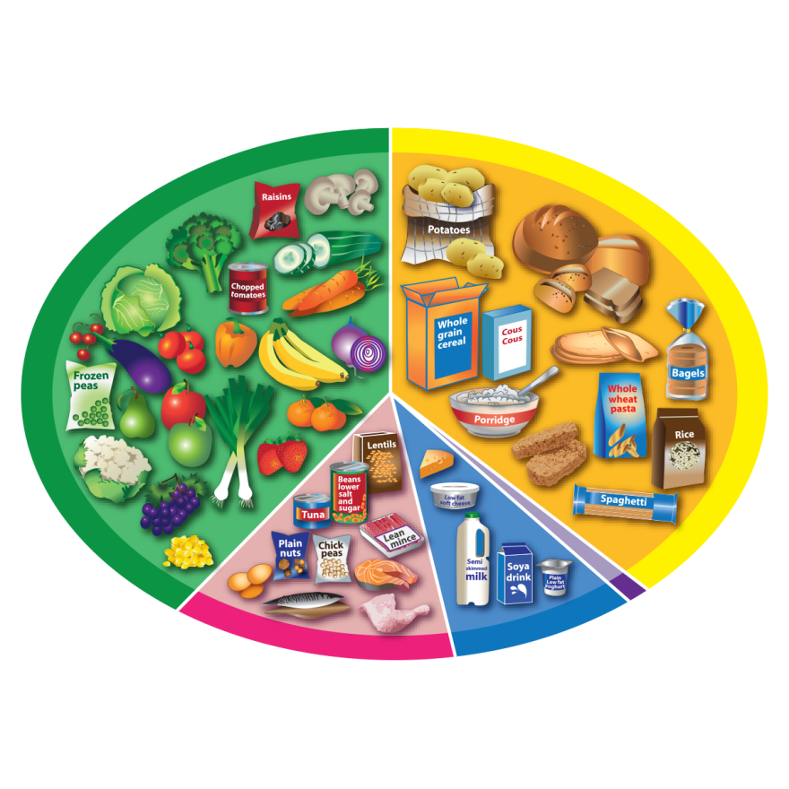
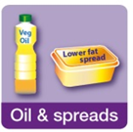
Eatwell guide – plant or animal?
Look at the main food groups on the Eatwell Guide.
Give examples of food from a plant and/or an animal for each group.

 | Plant | Animal
Fruit and vegetables

Potatoes, bread, rice, pasta …

Beans, pulses, fish, eggs, meat …
Dairy and alternatives

Oil and spreads

